Ideation Phase
Brainstorm & Idea Prioritization Template

Date | 29 september 2026
Team ID | 6ab3db0c6603573ccfb381c9
Project Name | AI WEATHER WISE
Maximum Marks | 4 Marks

Brainstorm & Idea Prioritization – AI WeatherWise
Brainstorming helps the team generate creative ideas for developing an intelligent weather forecasting system. Different ideas such as real-time weather updates, temperature prediction, rainfall alerts, weather-based recommendations, and API integration are discussed and evaluated.
The most useful ideas are prioritized based on accuracy, reliability, user needs, and ease of implementation. These selected ideas are then combined to develop AI WeatherWise, providing users with clear and intelligent weather forecasts and insights through real-time weather data.
Step-1: Team Gathering, Collaboration and Identification of the Weather Forecasting Problem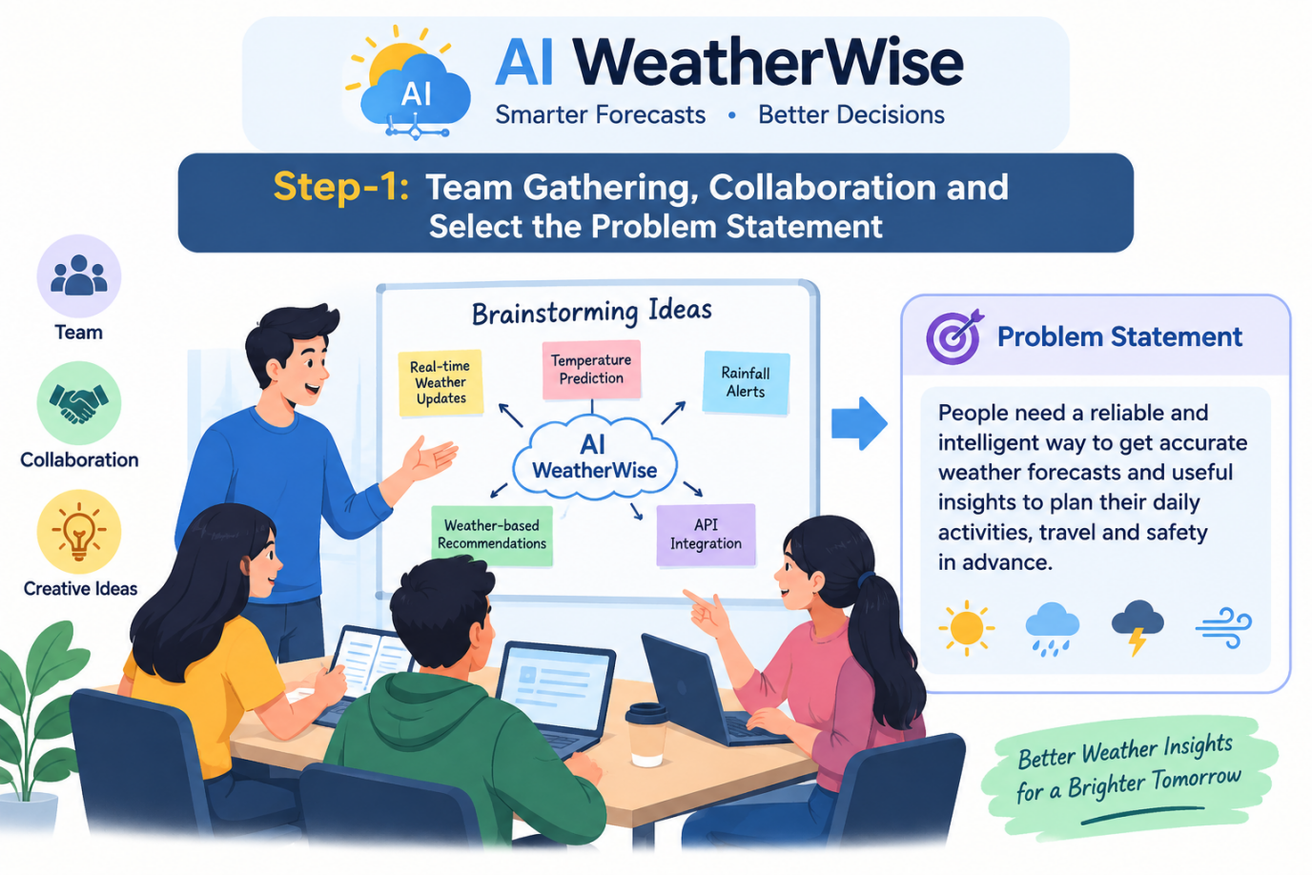

Step-2: Brainstorm, Idea Listing and Grouping for AI WeatherWise
